**WORKSHEET 6**

**Student Name:** Vivek Kumar **UID:** 21BCS8129

**DOMAIN CAMP:** 16-01-2023 to 28-01-2023 **Section/Group:** DWWC-77

**Subject Name:** IT Skills (DSA)

**Question 1. FAMILY TREE**

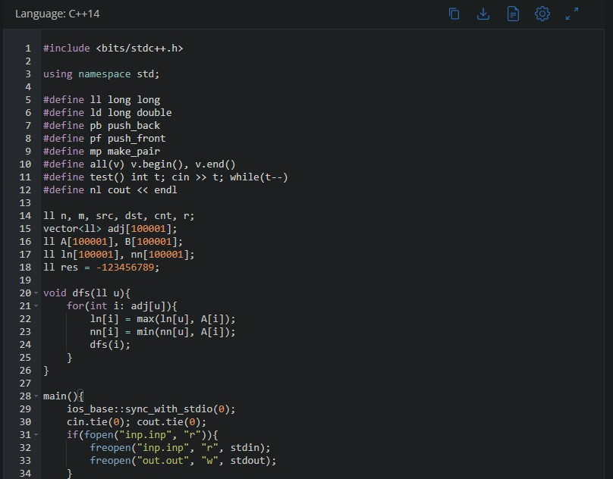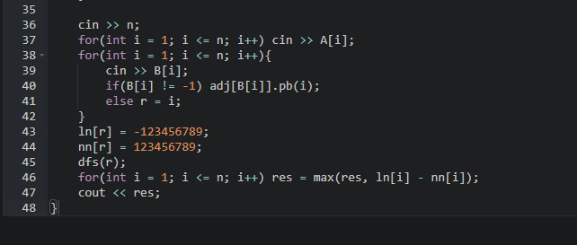

**SOLUTION:**

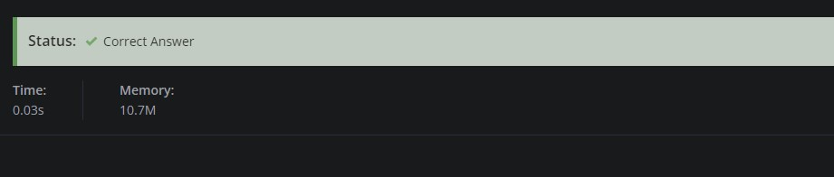

# Question 2. SHORTEST PATH IN BINARY TREES

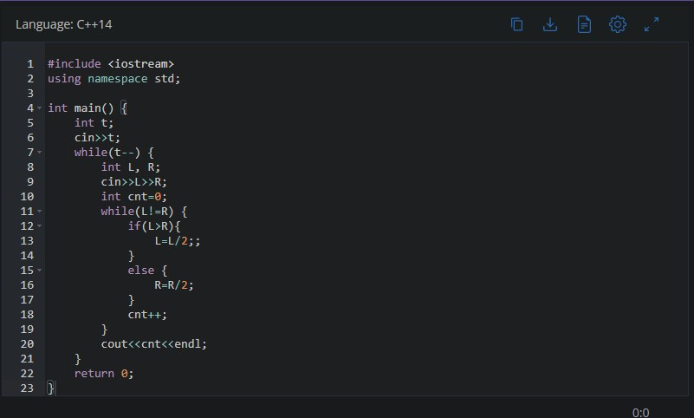

**SOLUTION:**

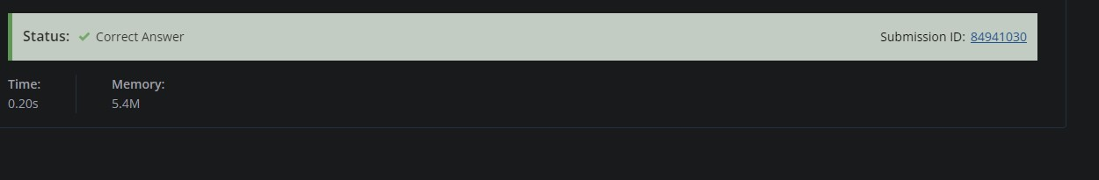

**Question 3. BLACK AND WHITE TREE**

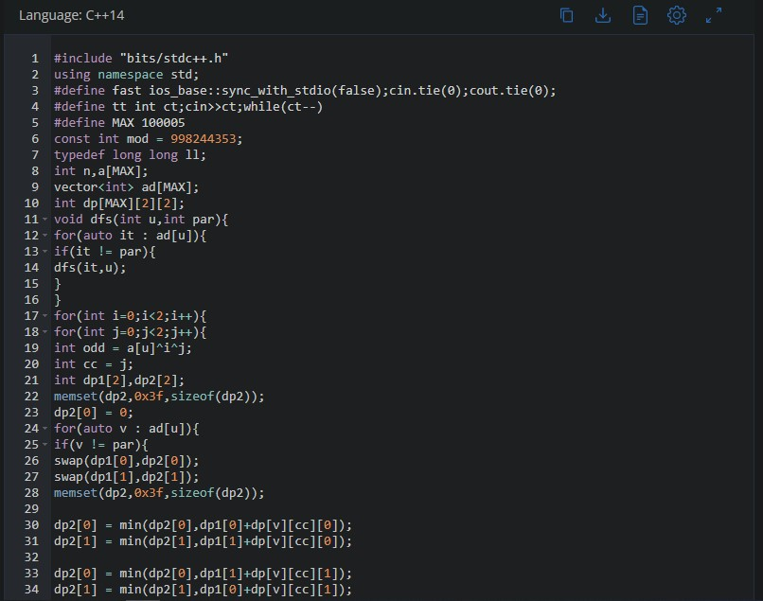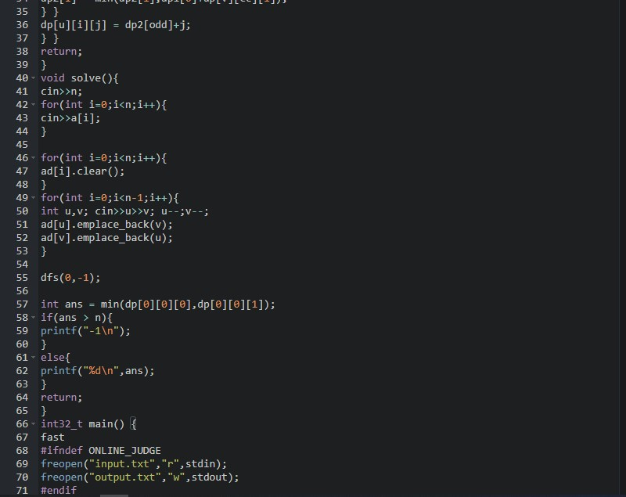

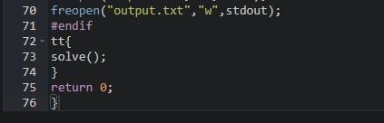

**SOLUTION:**

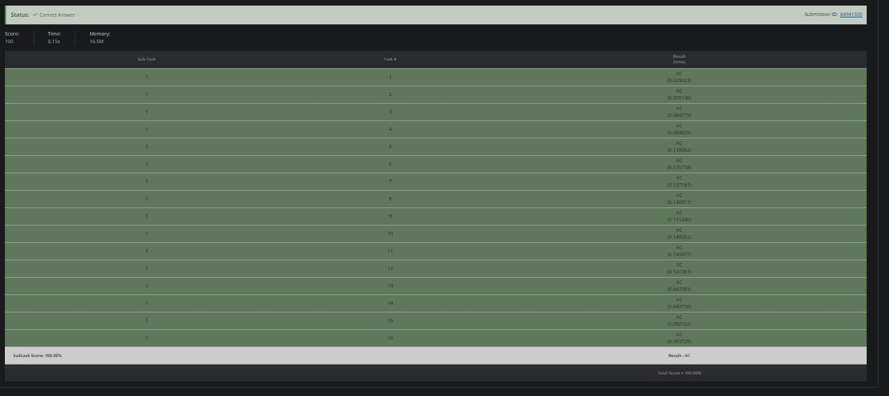

# Question 4. SECRET TREE

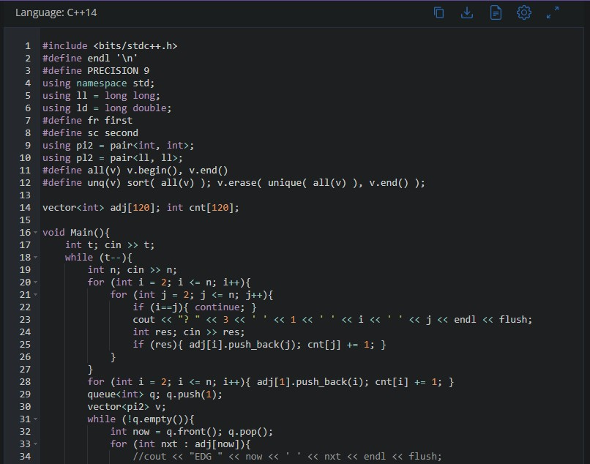

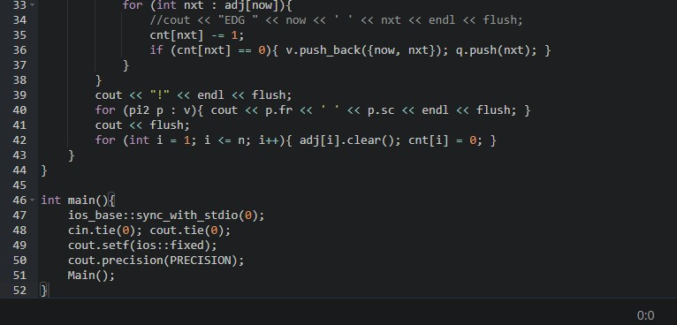

**SOLUTION:**

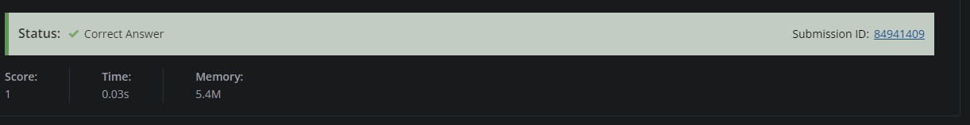

# Question 5. BLACK AND RED VERTICES OF TREE

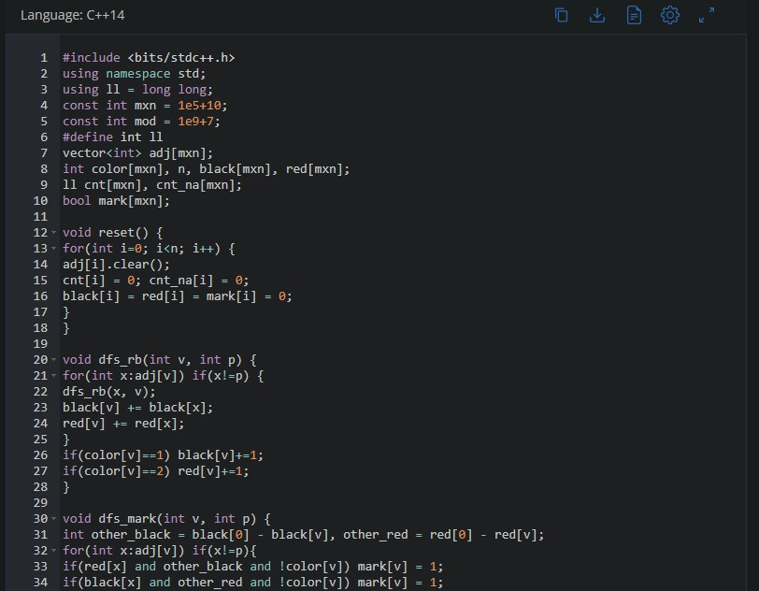

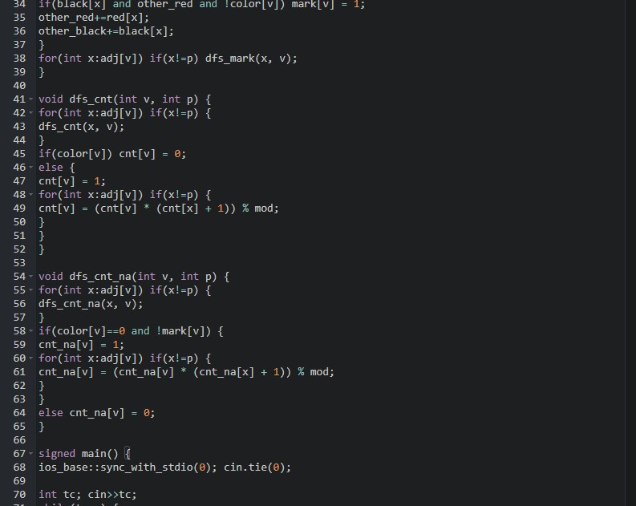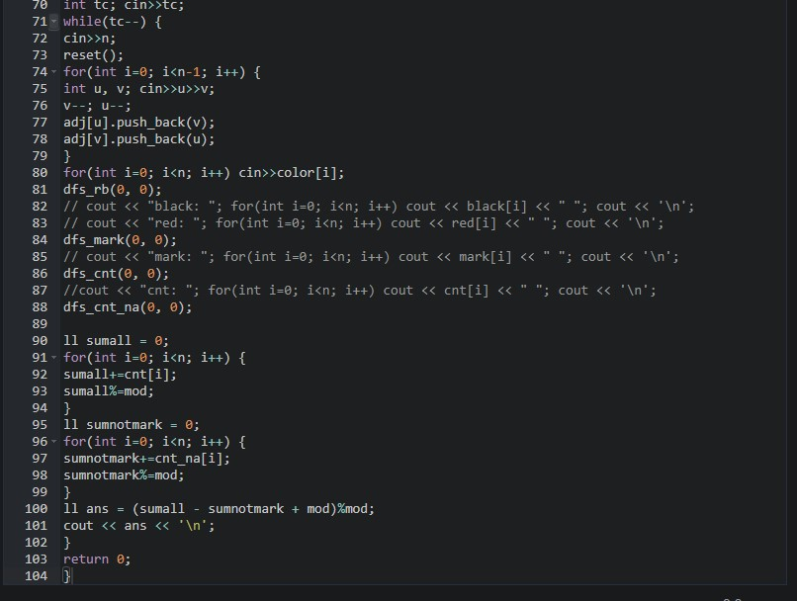

**SOLUTION:**

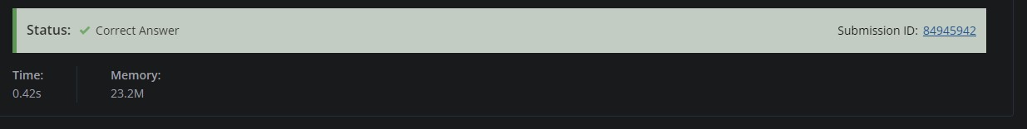

**Question 6. COMMON ANCESTORS**

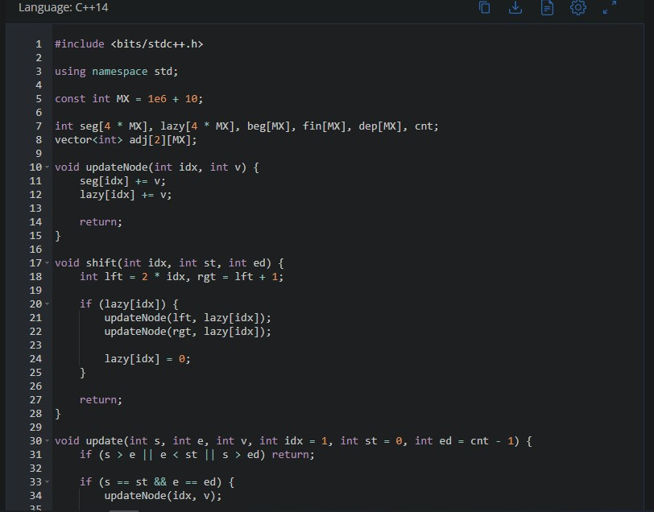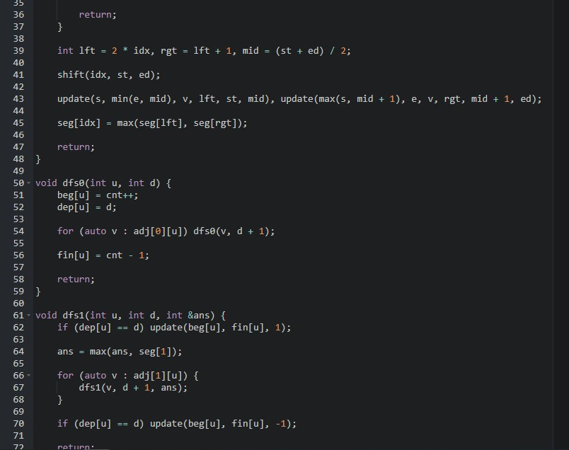

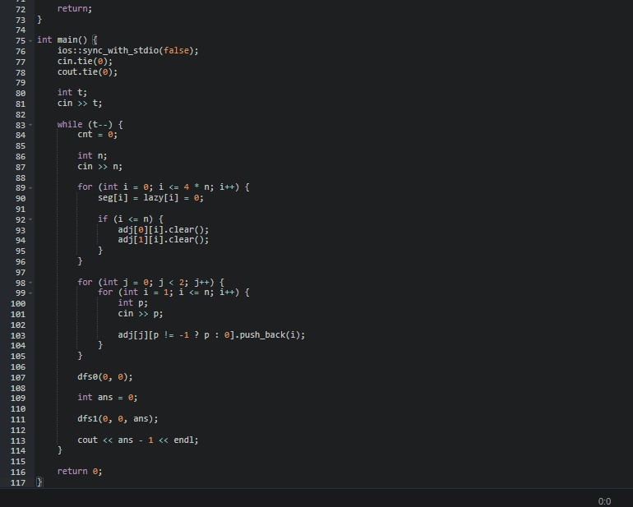

**SOLUTION:**

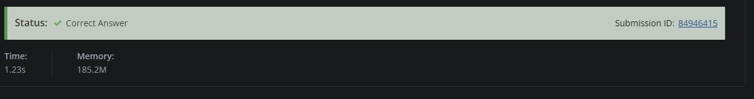

# Question 7. SUBTREE REMOVAL

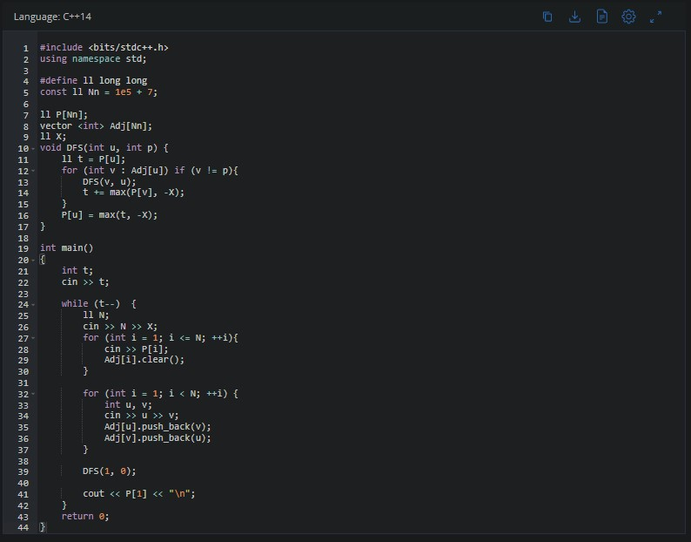

**SOLUTION:**

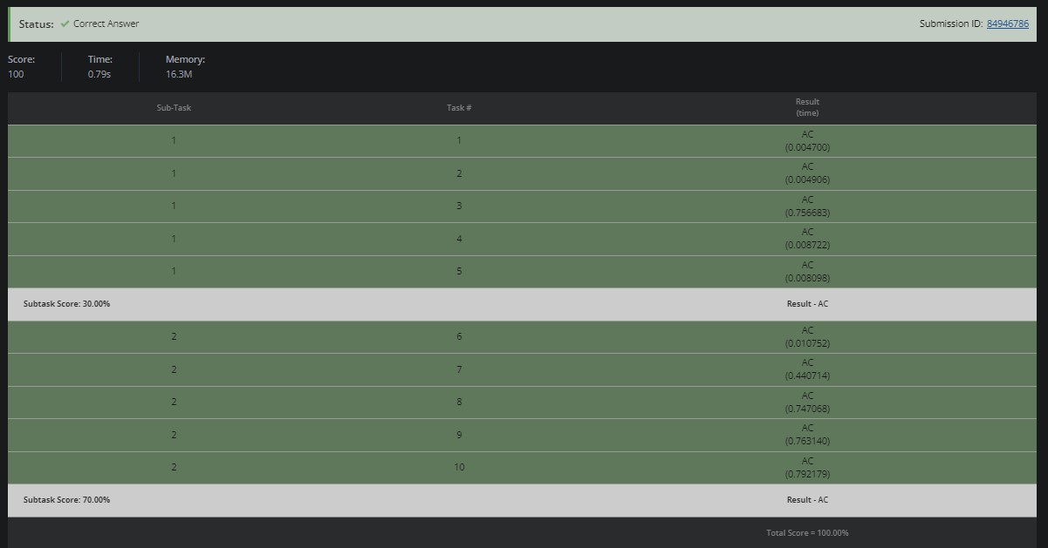

# Question 8. ALTERNATING DIAMETER

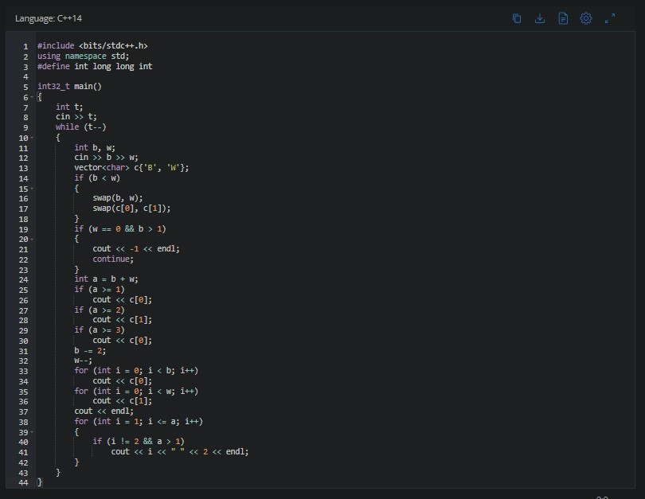

**SOLUTION:**

